Requesting an Update
- On My Dashboard scroll down to find relevant section 603 application. On the right hand side, change View “Last 5 days” to “All”.

- An alternative to quickly search for your certificate is – Find Existing Application
Search under either Application Number, Property Address or Lot and DP.

- When you have located your application and the status is Certificate Available, click Request Update.
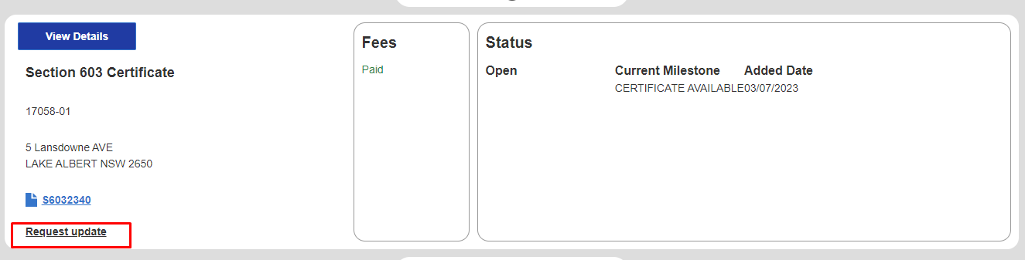
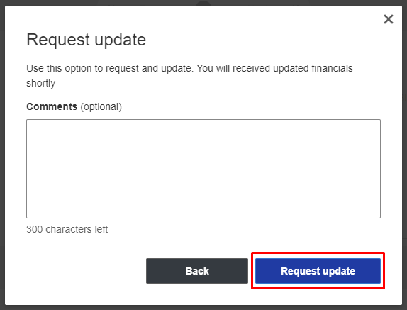

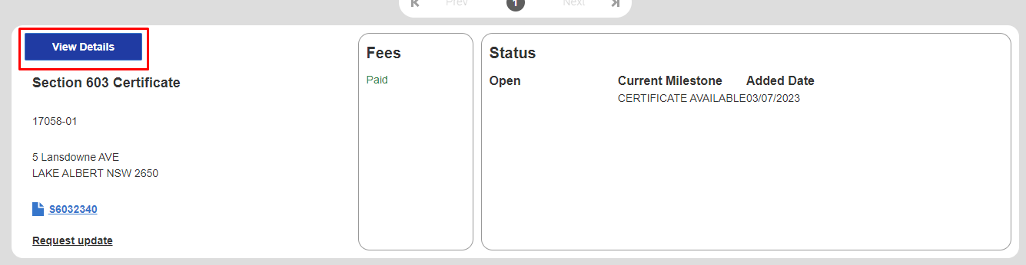
- Then View Details

- Certificate Update, when you click the drop-down button you will be able to view the date of update, updated account balance, transactions total since certificate provided and daily average consumption.
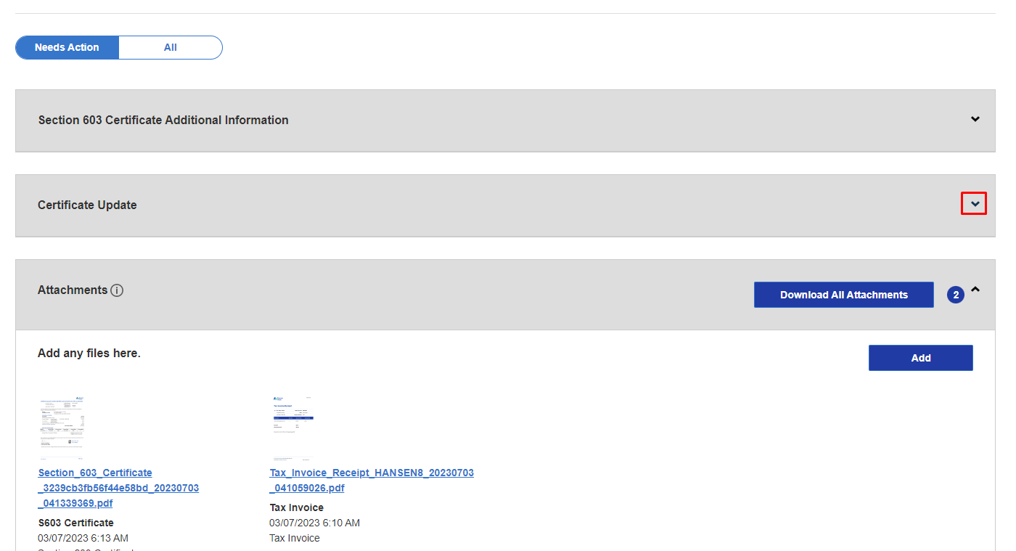
Your update will be available in the drop down menu.
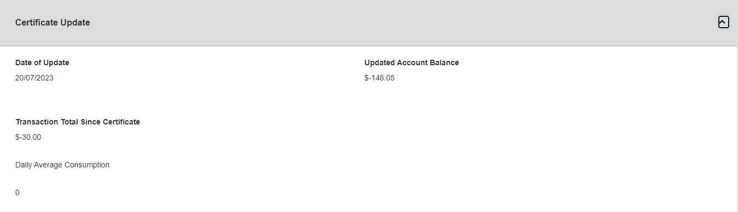

An update can be processed multiple times and will be accessible at all hours.
If you require any further assistance, please contact our Customer Service Team 02 6922 0608 or email admin@rwcc.nsw.gov.au.

